Huỳnh Thanh Dũng 17110016

KNN iris.data

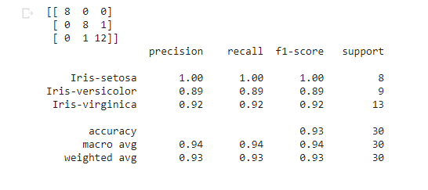

<https://colab.research.google.com/drive/1ZpNJEeDlGiuCdO2Iv2blqqdfWcSOoETe#scrollTo=2rsdd9mJMYqF>